UNE CARTE DE LA FRANCE

TASK: In this activity you will prepare a map of France.
- You will only be required to label certain things, so read the instructions carefully and take your time.

This assignment will be completed in FOUR steps.
STEP 1: TRACE (complete this step in pencil)
- Get a template of France from Mme Berry and trace the map of France onto a blank sheet of paper.

STEP 2: LABEL (complete this step in pencil)
- Use the provided maps and the map in your Discovering French textbook on page 4 to help you label your map.
- Only label the items listed below.
- Stay organized by checking off each box as you complete it.

NOTE: All labels must be spelled correctly and in French.

Label…
- the capital city of France with a star. Write the city’s name in CAPITAL LETTERS.
- the FOUR major rivers in France. Label the rivers using lower case letters and along the rivers.
- the THREE bodies of water surrounding France. Label these using CAPITAL LETTERS.
- the EIGHT countries surrounding France. Label the countries using CAPITAL LETTERS.
- any TWELVE cities in France (you choose). Label the cities using lower case letters.
- the TWO major mountain ranges in France. Label these using CAPITAL LETTERS.
- the name of the country “LA FRANCE” in the centre of your map. Use CAPITAL LETTERS.
- FIVE attractions in France using icons or artistic representations. Draw an image near the city or the location in France. Write the name of the attraction or monument beside your drawing.

STEP 3: REVIEW
Double check that you have ALL of the items above on your map. Check off the boxes one more time to be sure. Also, have you spelled everything correctly and in French?

STEP 4: COLOUR
Bring the map to life! Add colour.
- Colour the water blue.
- Colour the countries different colours
- Go over the names and borders in black so that they stand out.
- Be creative and have fun!

ASSESSMENT:
 | Level 4 | Level 3 | Level 2 | Level 1 | Below Level 1
Completion:  Are all steps completed? | 5 4  Evidence of thorough completion. | 3.5  Evidence of considerable completion. | 3  Evidence of some completion. | 2.5  Evidence of limited completion. | Task was not completed.
Accuracy:  How accurate is your map?  (includes spelling, accents & locations) | 10 9 8  Task completed with a high degree of accuracy. | 7.5 7  Task completed with considerable accuracy. | 6.5 6  Task completed with some accuracy. | 5.5 5  Task completed with limited accuracy. | Task lacks any accuracy.
Clarity:  Is your map neatly traced, labelled and coloured? | 5 4  Map is very effective with a high degree of clarity. | 3.5  Maps is effective with considerable clarity. | 3  Map is somewhat effective with some clarity. | 2.5  Map has limited effectiveness with limited clarity. | Map is not effective with a lack of clarity.

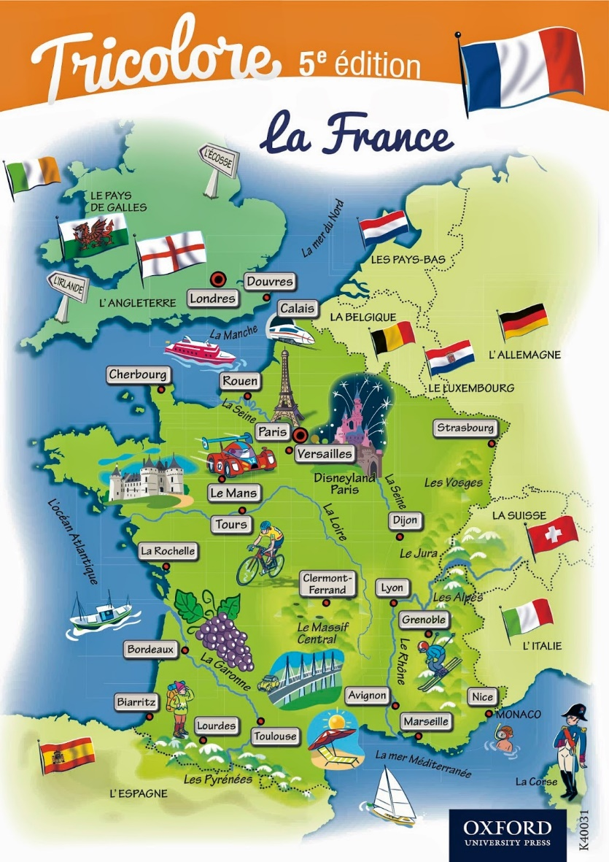
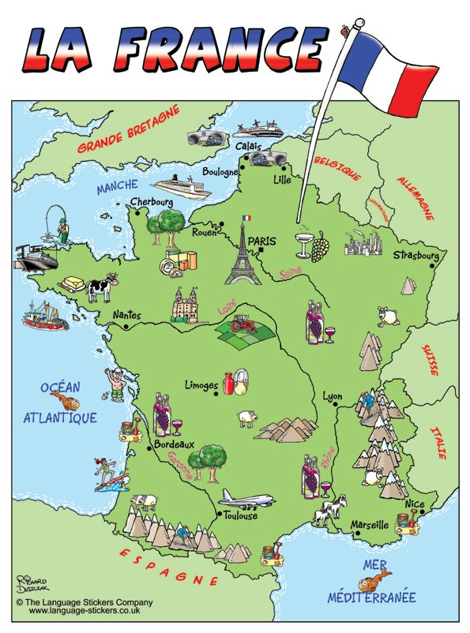
LES CARTES:

